MACH4METAL

Metalworking machinery
Transito 21,
6909 DA BABBERICH
Netherlands
Tel. +31 (0)316 – 247123
Fax. +31 (0)316 - 247956
info@mach4metal.com
www.mach4metal.com

Account No: 66.52.13.883
IBAN : NL33 INGB 0665 2138 83
BIC : INGBNL2A

CNC TOS WHN 13.8 C Horizontal borer

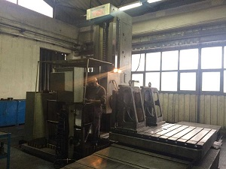
- Make : TOS Varnsdorf
- Typ : WHN 13 CNC
- Serial : 09 15
- Age : 1996

- Spindle : iso 50
- Diam : Ø 130

- Power : 37 kW
- Speeds : Vario 1 – 1.500 Rpm
- Torq on spindle 5.000 Nm
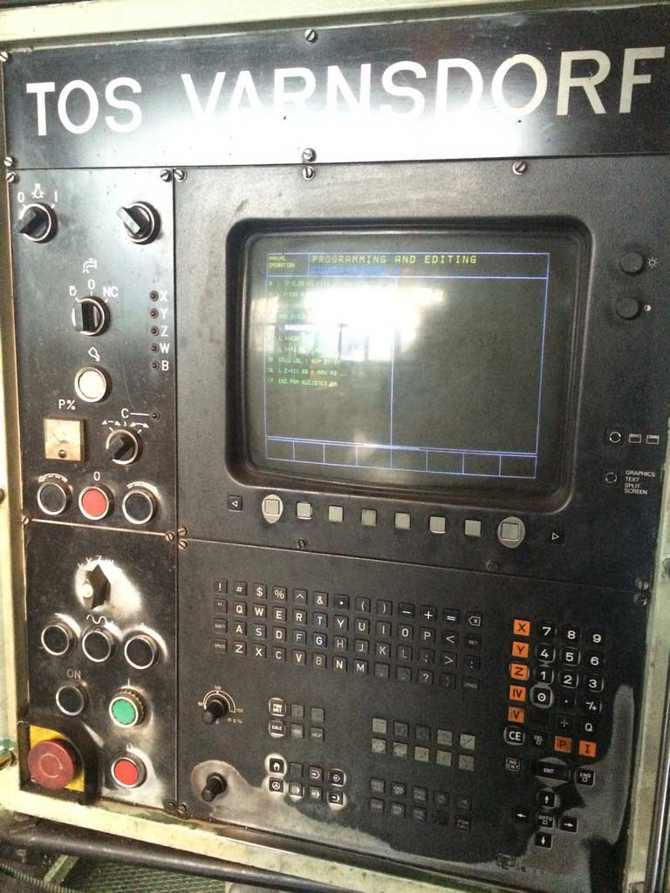
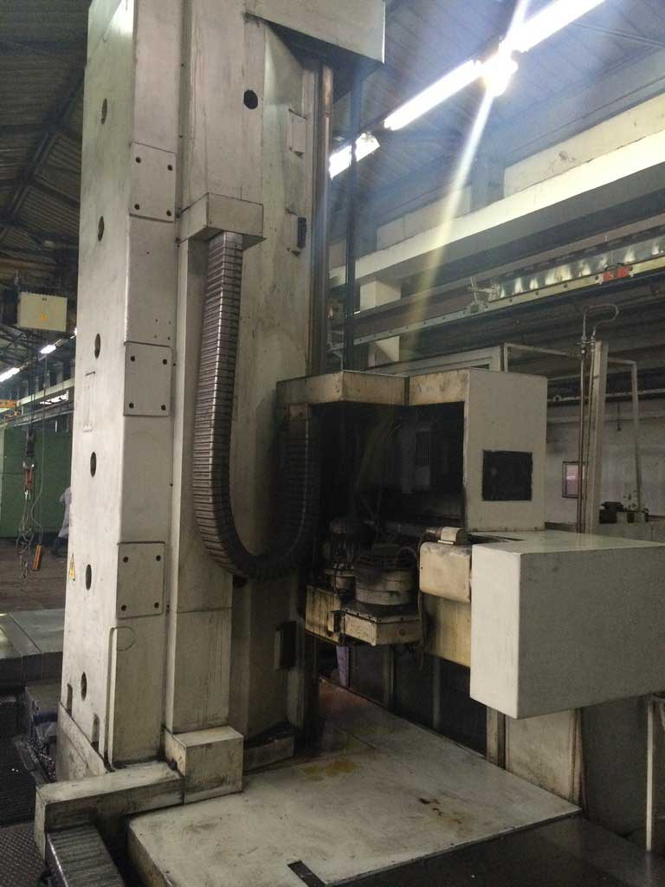
- X : 3.500
- Y : 2.000
- Z : 800
- W : 1.250

- Table size : 1.800 x 1.600
- Load on table : 12.000 Kg

- Feeds X-Y-Z-W : 1 – 6.000 mm/min.
- Rapid X-Y-Z-W : 1 – 8.000 mm/min.
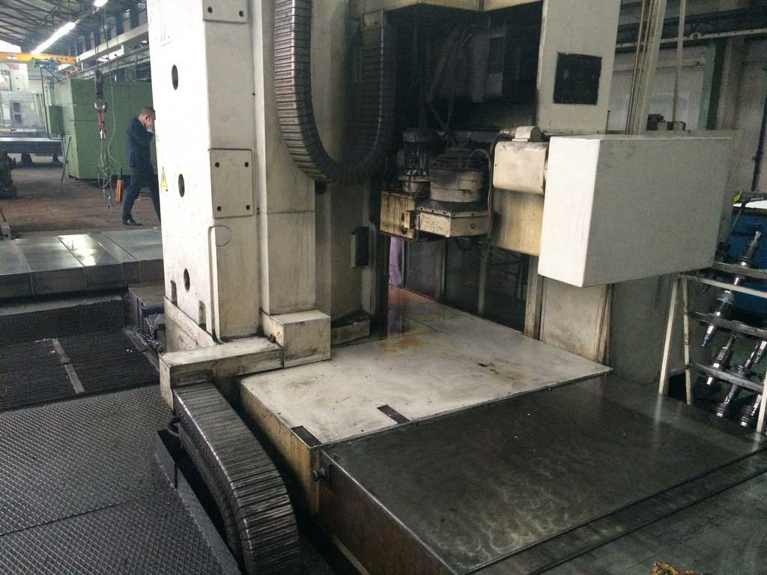

- CNC HeidenHain TNC 415 in 5 Axis

- Dimensions 7.725 x 5.695 x 4.885
- Weight 33.000 Kg

Please Note: The above information has been obtained to the best of our ability and belief from, and from the manufacturers where possible. It is given in good faith, but its accuracy can not be guaranteed. Accordingly, it will not form a representation or constitute contractual terms. We advise you to check any vital details!

